

EE462 & EE464 Project: Design of a SM-PMSM Variable Frequency Drive with Matlab/Simulink

Hakkı GÜLCÜ

Tel: +90 534 397 29 66

mail: [hakkigulcu35@gmail.com](mailto:hakkigulcu35@gmail.com)

2093862

Özgür

Tel: +90 535 938 69 20

mail: [xxxxxxx](mailto:bulbulbahar@gmail.com)

209xxxxx

**Supervisor:** Ozan KEYSAN & Emine BOSTANCI

Date of Submission: 02.06.2019

# Introduction

The aim of project is to design a SM-PMSM Variable Frequency Drive with respect to given parameters below by using matlab Simulink program.

𝑃𝑛𝑜𝑚𝑖𝑛𝑎𝑙 = 80 𝑘𝑊

T𝑛𝑜𝑚𝑖𝑛𝑎𝑙 = 300 𝑁𝑚

𝑛𝑚𝑎𝑥 = 7000 𝑟𝑝𝑚

Pole number: p=8

𝐹𝑙𝑢𝑥 𝑙𝑖𝑛𝑘𝑎𝑔𝑒: 𝜆𝑃𝑀 = 0.2 Vs (Wb-t)

𝐿𝑑 = 𝐿𝑞 = 500 uH

𝐼𝑛𝑜𝑚𝑖𝑛𝑎𝑙 = 250 𝐴 (peak)

Phase resistance 𝑅𝑠 = 50 mOhm

Equivalent inertia of the system: 𝐽𝑒𝑞 = 10 kg m2

Ignore windage and friction losses.

The available supply is a three-phase AC source (50 Hz, 400Vl-l) and the PM is a surface-mount motor. Assume a 3-phase full-bridge diode rectifier is connected to the grid.

# Part A: Pre-design Stage

## Calculation of the rated speed and torque of the PMSM.

Wbase=== 266.67 rad/sec , Nbase=2546.48

T= $\frac{3}{2}*pp*$ 𝜆𝑃𝑀*iq Where nomimal base Torque condition,İq=İnominal =250 A , İd=0

Then T=1.5*4(pp)*0.2*250 = 300Nm where it is also given in parameters.

## Calculation of the maximum applied electrical frequency and choose a switching frequency for your inverter

We=2*π*f , then frequency= $\frac{We}{2*π}$

where from part a We(max)= $\frac{7000rpm*2*π}{180}$ is found 733 rad/sec,

fmax= $\frac{733}{2*π}$ =116.67 Hz

Selected Swich frequency=10k

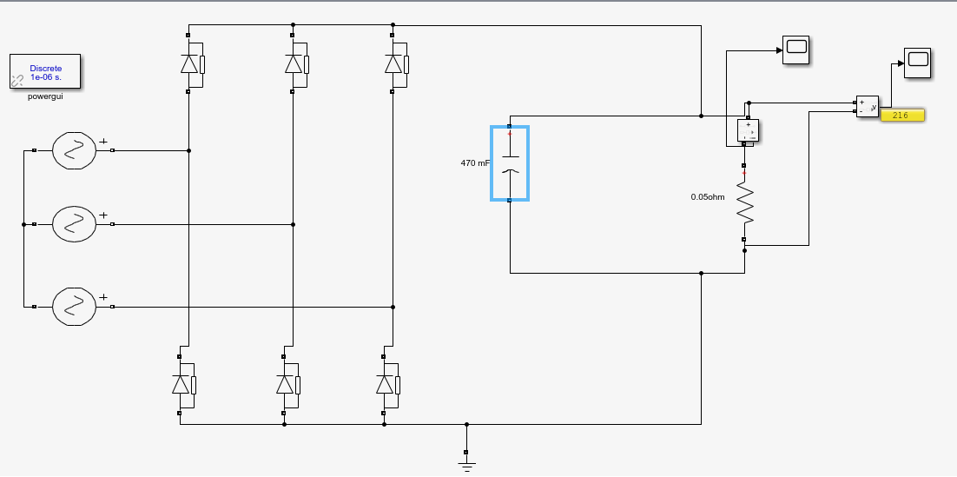

Figure :Design of DC-link filter for the rectifier block

We select the capacitor as 470 mF in order to decreases the voltage ripple.

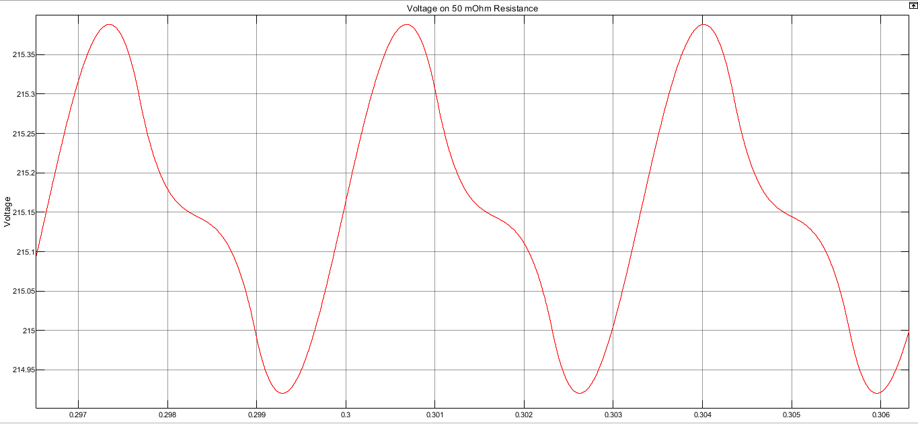

Figure : Plot of the DC-link voltage waveform by connecting a resistive load equivalent to motor.

As seen figure 2. Voltage ripple is about 0.4 V. Avarage DC-link voltage as 215.15 .

Then, Ripple = 100 $\frac{0.4}{215.15}=\%0.2$* , This is so efficient result for our design.